International Winter Session Office Nanchang University, XueFu road 999 Nanchang, JiangXi Province, 330031, P. R. China

Phone: +086-791-86512582

[E-mail:iss@ncu.edu.cn](mailto:iss@ncu.edu.cn)

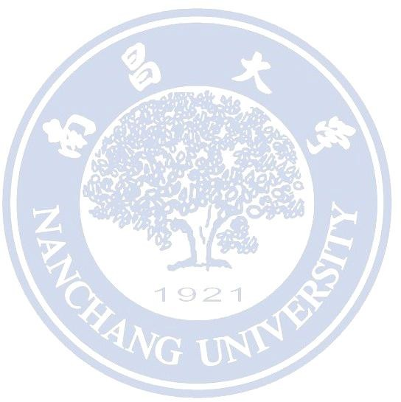Please read the notes overleaf before completing this form.

# *PARTICULARS OF STUDENT*

Student Name: Student No: Programme Title: Phone Number:

# *CONTENT OF PERSONAL INFORMATION*

Name in English: Name in Chinese: Student’s ID:

Date of Birth: Gender: Nationality:

***I declare that all the particulars provided above are true and correct to the best of my knowledge.***

**Signature of Student Date**

# *FEE*

Nanchang University International Winter Session Fees

|  |  |  |
| --- | --- | --- |
| Numbers of courses taken | Online courses fee | On-campus courses fee |
| 1 | ¥17800 | ¥19800 |
| 2 | ¥25800 | ¥27800 |
| 3 | ¥31800 | ¥33800 |
| 4 | ¥37800 | ¥39800 |
| 5 | ¥43800 | ¥45800 |
| 6 | ¥49800 | ¥51800 |

# *REQUIRED MATERIALS*

-Copy of Valid Passport or ID

-Certificate of University Enrollment or Copy of Student ID

-Proof of English Proficiency

-Head-and-shoulders Photo

# *BE AWARE:*

Our program requires all students to prove their English language proficiency in the application. You must be qualified for at least one of the following conditions to pass our English language proficiency requirement.

1. English native speaker
2. Studying or Graduated from an institution where English is the main language of instruction
3. Have a valid TOEFL (Test of English as a Foreign Language) score which is higher than 80 (IBT) or equivalent scores in other forms of TOEFL tests
4. Have a valid IELTS (International English Language Testing System) score which is higher than 6.0
5. (For students in Chinese universities) Successfully passed CET-4 or other equivalent / higher level standard tests

*If you do not fulfill any of them, Students can contact the admission office for a phone interview to prove your English proficiency.